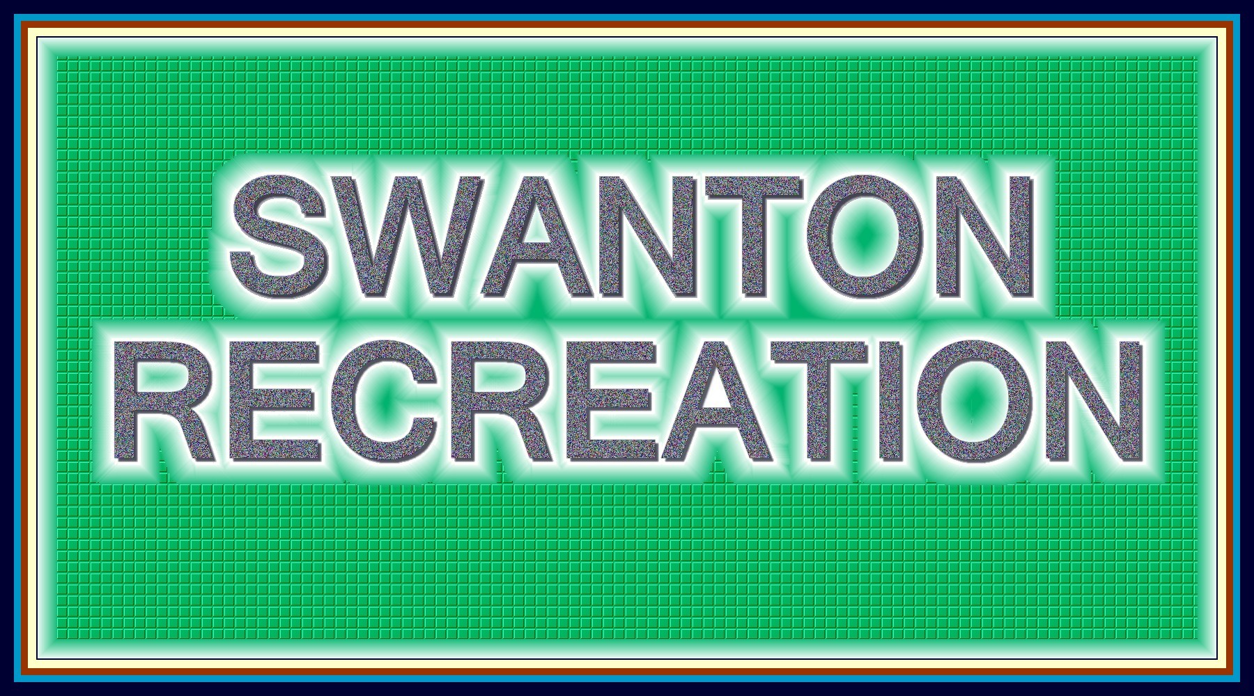
Swanton Recreation Commission
Meeting Agenda
November 17, 2014 @ 6:00 pm
Location: 16 Jewett Street

Open Meeting
Agenda Review
Approve October Meeting Minutes
Directors Reports
Space
Budget Review
Other business
Closed Session
Next meeting date
Close meeting
www.swantonrec.org
802-868-2493

