2014 DEDICATION
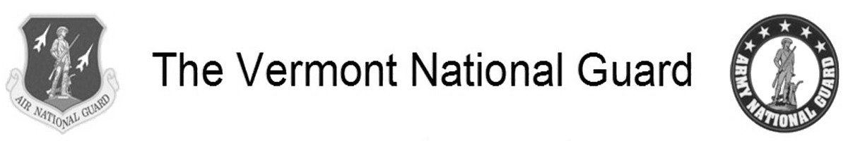
The Town of Swanton 2014 Annual Report is respectfully dedicated to the men and women who serve in the Vermont National Guard especially those who are residents of Swanton. The Vermont National Guard is made up of the Vermont Army National Guard (VANG) and the Vermont Air National Guard (VTANG). Swanton has approximately 25 members serving in the Vermont Air National Guard and approximately 55 members serving in the Vermont Army National Guard. Members of both branches of the Vermont National Guard have been historically named “The Green Mountain Boys” and continue to carry on the valiant service of their colonial namesakes.
The Vermont National Guard’s Delta Company of the 186th Brigade Support Battalion, 86th Infantry Brigade Combat Team (Mountain) is based in Swanton. The 158th Fighter Wing of the Vermont Air National Guard is based at the Burlington Airport. In the fall of 2014, Swanton was honored by having one of VTANG’s F16C jets named after Swanton thus giving the jet and its pilots a special relationship with our community.
The Vermont National Guard is a band of brothers and sisters committed to providing disaster support operations to our towns and state as well as engaging in international operations to keep our country safe from foreign enemies. Several of the 21 statewide units of the Guard have served on federal missions throughout the world in such diverse and dangerous places as Iraq, Afghanistan, Kosovo, Bosnia, Saudi Arabia, Horn of Africa, Qatar, Kuwait, and Korea. The Swanton Guard units based in town and at the Burlington Airport have served on federal missions in Afghanistan and Iraq.
Members of the Vermont National Guard know the value of leadership, sacrifice, teamwork, discipline, duty, and pride. Their respect is earned, not given. Serving one’s state and country in uniform is a special calling. Freedom is not free – it must be protected by the members of our military organizations, including the Vermont National Guard, in order to be enjoyed by the rest of us. Through the intense courage and dedication of the Vermont National Guard, our freedom is kept intact and our state and nation are safer places.
Therefore, it is with great honor and respect that we dedicate the 2014 Annual Report to the Vermont National Guard with special hometown recognition to those Swanton residents who serve in the Vermont Army National Guard and the Vermont Air National Guard.
Thank you all for your very much appreciated service! - The Town of Swanton Selectboard
